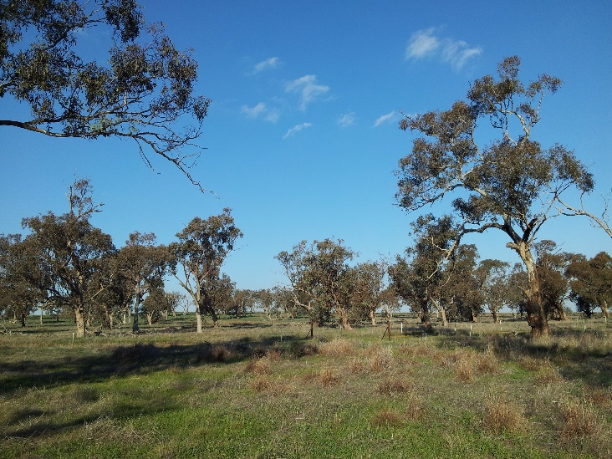
Figure S1. Typical study site, showing widely dispersed trees and lack of understory (source: Corresponding author)
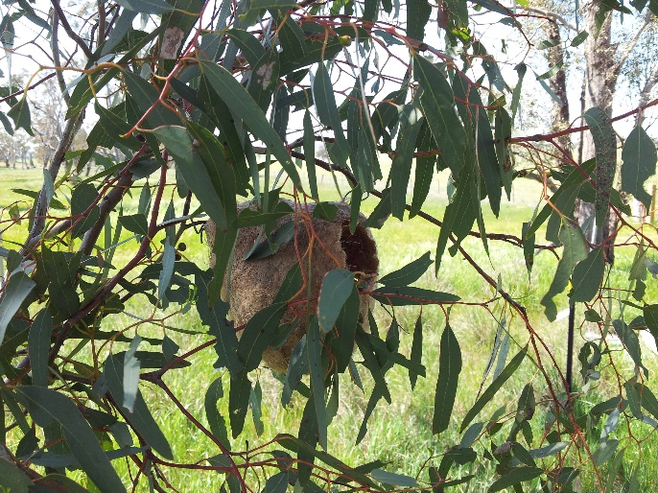 | 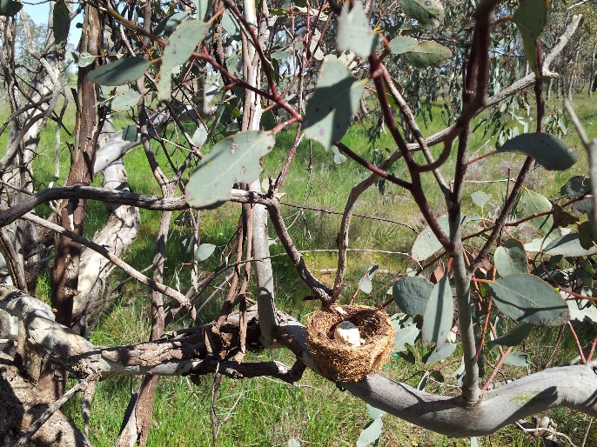
Figure S2. Nest types used in study. a) Dome, b) Cup. (Source: Corresponding author)

Figure S3. Contribution of nest predators to total nest predation over the whole study
(Treatment and Control sites combined)

Figure S4. Contribution of nest predators to total artificial nest predation in treatment and control sites respectively
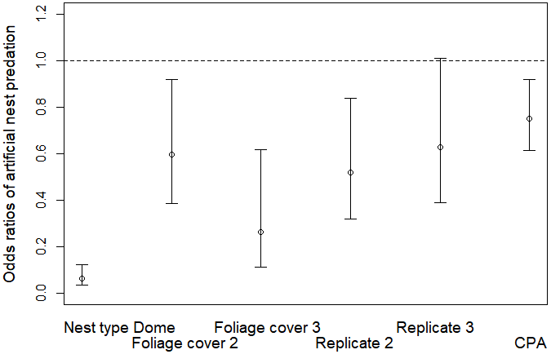
Figure S5. Effects of other significant explanatory variables on odds ratios of artificial nest predation. Odds ratios of nest predation for categorical variables are with respect to reference values Nest type cup, Foliage cover 1 and Replicate 1 respectively. For example, the plot for Nest type dome represents the ratio
$$\frac{Expected odds of artificial nest predation in dome nests }{Expected odds of artificial nest predation in cup nests}$$
For the continuous variable, CPA, the plot indicates that a one unit increase in CPA corresponds to an expected reduction in odds of nest predation of 0.75.

Figure S6. (a) Expected noisy miner abundances over the two breeding seasons of the study, with 95% confidence intervals. The dotted line at 1.2 birds/2ha is the impact threshold of noisy miner abundance on species assemblages (Thomson et al 2015). (b) Relative differences in expected noisy miner abundance in the breeding seasons before and after the cull in treatment and control sites respectively, with 95% confidence intervals. The dotted line at 1.0 represents a ratio of 1 i.e. no difference between the expected abundances. Rightmost plot represents the Treatment:Phase interaction effect i.e. the relative difference in the change in noisy miner abundance between treatment and control sites shown in the previous two plots.

Calculating expected odds of artificial nest predation (ANP)

Regression equation for best model (ignoring random effects)
Ln expected odds of ANP = β₀ + β₁ Treatment + β₂ Phase + β₃ Treatment:Phase +
β₄ FoliageCover2 + β₅FoliageCover3 + β₆ NestType + β₇ CPA + β₈ Replicate 2 + β₉ Replicate 3 + β₁₀Phase:NestType

Table S1. Using addition of logs to calculate ln expected odds of ANP for phase, treatment and phase:treatment interaction, assuming constant values for other model variables
 | Control | Treatment
Phase 0 (before cull) | (β₀) | (β₀ + β₁)
Phase 1  (after cull) | (β₀ + β₂) | (β₀ + β₁ + β₂ + β₃)

To calculate the Treatment:Phase effect:
- Calculate relative change in ln expected odds of ANP before and after the cull in treatment and control sites respectively:
$Relative change in expected odds of ANP =$
$$\frac{Expected odds after cull }{Expected odds before cull }$$
- Calculate the relative difference between the change in expected odds of artificial nest predation in treatment and control sites to show effect of treatment:phase interaction:
$Relative difference between change in expected odds in$treatment and control sites =
$$\frac{\frac{Expected odds after cull }{Expected odds before cull } \left(Treatment\right)}{\frac{Expected odds after cull }{Expected odds before cull } \left(Control\right)}$$
$$= \frac{\frac{exp⁡\left(β_{0}+β_{1}+β_{2}+β_{3}\right)}{exp⁡\left(β_{0}+β_{2}\right)}}{\frac{exp⁡\left(β_{0}+β_{1}\right)}{exp⁡\left(β_{0}\right)}}=exp⁡\left(β_{3}\right)$$

Worked example (using best model):
Table S2. Model output
Predictor | Coefficient estimate (logit link)
Intercept | 1.34
Treatment | 0.04
Phase | -0.48
Treatment:phase | -0.32

Table S3: Calculating ln expected odds ANP by treatment and phase using addition of logs (with exponentiated values in brackets) (see Figure 3(a), main document)
 | Control | Treatment
Phase 0 (before cull) | 1.34 (3.84) | 1.34 + 0.04 = 1.38 (3.97)
Phase 1  (after cull) | 1.34 – 0.48 = 0.86 (2.36) | 1.34 + 0.04 – 0.48 – 0.32 = 0.58 (1.79)

Changes in expected odds of ANP due to effects of, respectively, Treatment, Phase and Treatment:Phase interaction (using back-transformed coefficients):
Change in Treatment sites = (Treatment, Phase 1)/ (Treatment, Phase 0) = 1.79/3.97 = 0.45
(55% decline)
Change in Control sites = (Control, Phase 1)/(Control, Phase 0) = 2.36/3.84 = 0.61
(39% decline)
Ratio of changes in Treatment to change in Control = 0.45/0.61 = 0.74 (see Figure 3(b), main document)
Table S4. Model parameters used in best model as predictors of odds of artificial nest predation. Effect size and uncertainty (95% confidence intervals) are shown for fixed effects. Random effects were not included as they did not improve model fit. Note i) due to the logit model’s log link function, original model output gives coefficient estimates for the log of the dependent variable. In this table, values have been back-transformed (see worked example above). Hence, for categorical variables, coefficient estimates represent the relative change in expected odds of ANP for a change from the reference level of the corresponding explanatory variable. For the continuous variable CPA, the coefficient estimate represents the relative change in expected odds of ANP for a unit change in CPA.
Fixed effects  (back-transformed) | Coefficient  estimate (back-transformed) | Lower  confidence  interval | Upper  confidence  interval
Intercept | 3.84 | 2.08 | 7.08
Treatment | 1.04 | 0.57 | 1.87
Phase | 0.62 | 0.33 | 1.16
Treatment: Phase | 0.73 | 0.33 | 1.61
Nest type | 0.06 | 0.03 | 0.12
Phase:Nest type | 4.22 | 1.81 | 9.82
Foliage cover 2 | 0.59 | 0.38 | 0.92
Foliage cover 3 | 0.26 | 0.11 | 0.62
CPA | 0.75 | 0.61 | 0.92
Replicate 2 | 0.52 | 0.32 | 0.84
Replicate 3 | 0.63 | 0.39 | 1.01

Table S5. Summary of best candidate models produced by the R package MuMIn which included the BACI base model (Treatment, Phase, Treatment:Phase).
Model | AIC | ΔAIC | No. of variables
Base + CPA + Foliage cover + Nest type + Replicate + Nest type:Phase | 622.7 | 0.0 | 8
Base + CPA + Foliage cover + Nest type + Other predator density + Replicate + Nest type:Phase | 623.1 | 0.4 | 9
Base + CPA + Area + Foliage cover + Nest type + Other predator density + Replicate + Nest type:Phase | 623.7 | 1.0 | 10
Base + CPA + Area + Foliage cover + Nest type + Other predator density + Total stems + Replicate + Nest type:Phase | 623.9 | 1.2 | 10
Base + CPA + Area + Foliage cover + Nest type + Replicate + Treatment + Nest type:Phase | 624.1 | 1.3 | 9
Base + CPA + Foliage cover + Other predator density + Nest type + Replicate + TWI + Nest type:Phase | 624.5 | 1.8 | 10
Base + CPA + Nest type + Other predator density + Noisy miner density + Replicate + Treatment + Nest type:Phase | 624.7 | 2.0 | 10
Base + CPA + Foliage cover + Nest type + Replicate + Total stems + Nest type:Phase | 624.8 | 2.1 | 9

Table S6. Coefficients for Firth logistic regression (with 95% confidence intervals).
 | Coefficient | Lower confidence  interval | Upper confidence interval
Intercept | 2.08 | 0.20 | 3.96
Treatment | 2.62 | -2.76 | 7.99
Phase | 0.55 | -2.02 | 3.12
Treatment:Phase | 3.02 | -35.68 | 41.73

