Supplementary materials

Supplementary information for:
Rowland, J. A., Bracey, C., Moore, J.L., Cook, C.N., Bragge, P. and Walsh, J.C. (2021) Effectiveness of conservation interventions globally for peatlands in cool-climate regions. Biological Conservation.

List of appendices
Appendix 1 – Glossary of terms
Appendix 2 – Details of literature search, including the pilot search and search string
Appendix 3 – Supplementary results: critical appraisal details
Appendix 4 – Supplementary figures
Appendix 5 – Supplementary references
Appendix 6 – Spreadsheet including metadata for each tab (tab 1), details of included/excluded papers (tab 2), details of included papers (tab 3), critical appraisal of systematic reviews (tab 4) and narrative reviews (tab 5), data extracted from included reviews (tab 6) and Peatland Synopsis (tab 7), and metadata (tab 7).

Appendix 1. Glossary
Table S1. Glossary of terms
Terms | Description
Bog | A type of peatland which derive water and nutrients mainly from rain. They are highly acidic environments which are low in nutrients (Taylor et al. 2018).
Conservation | The protection, care, management and maintenance of ecosystems, habitats, wildlife species and populations, within or outside of their natural environments, in order to safeguard the natural conditions for their long-term permanence (IUCN, 2021).
Ecosystem restoration | ﻿The process of assisting the recovery of an ecosystem that has been degraded, damaged or destroyed (Mcdonald et al., 2016)
Fen | A type of peatland that derives water and nutrients from ground water and rain sources. Compared to bogs, there are more nutrients available and are less acidic (Taylor et al. 2018).
Meta-analysis | A review method that combines evidence gathered from individual studies to quantitatively evaluate overall trends or effect sizes (Cook et al., 2017), usually conducted via a systematic review.
Mire | A peatland where peat is currently forming and accumulating (Parish et al. 2008).
Peatland | Peatlands are a type of palustrine wetland ecosystem which are made up of partially decomposed organic matter (peat) (Page and Baird 2016).
Narrative review | A review method that provides a qualitative review of the literature on a topic and often did not use a systematic search protocol (Cook et al., 2017).
Systematic review | A review method that provides a transparent, repeatable evaluation of evidence for a specific question with the aim to reduce publication bias and uncertainty (e.g., by reporting a priori questions and protocol, having specific search criteria, and searching multiple databases with a consistent word string) (Cook et al., 2017).
References

Cook, C. N. et al. (2017) ‘Simplifying the selection of evidence synthesis methods to inform environmental decisions: A guide for decision makers and scientists’, Biological Conservation. Elsevier, 213(June), pp. 135–145. doi: 10.1016/j.biocon.2017.07.004.
IUCN. (2021). IUCN glossary of definitions. Retrieved from https://www.iucn.org/sites/dev/files/iucn-glossary-of-definitions_en_2021.05.pdf
Mcdonald, T., Gann, G. D., Jonson, J., & Dixon, K. W. (2016). International standards for the practice of ecological restoration - including principles and key concepts. First Edition (pp. 427–437). pp. 427–437. doi: 10.1016/b978-0-08-034092-0.50030-2
Page SE, Baird AJ. 2016. Peatlands and Global Change: Response and Resilience. Annual Review of Environment and Resources 41:35–57.

Parish, F., Sirin, A., Charman, D., Joosten, H., Minayeva, T., Silvius, M. and Stringer, L. (Eds.) 2008. Assessment on Peatlands, Biodiversity and Climate Change: Main Report. Global Environment Centre, Kuala Lumpur and Wetlands International, Wageningen.

Taylor N.G., Grillas P. & Sutherland W.J. (2018) Peatland Conservation: Global Evidence for the Effects of Interventions to Conserve Peatland Vegetation. Synopses of Conservation Evidence Series. University of Cambridge, Cambridge, UK.

Appendix 2. Literature search

Pilot search
We conducted an initial search of the two academic databases Web of Science and Scopus in March 2020. To refine our ecosystem (Population) search terms, we used a preliminary search string including the terms (bogs OR bog OR fen OR fens OR mire OR mires OR peat OR peats OR peatland OR peatlands OR moor OR moors OR sphagnum OR “wet heath”). Of the search results, we used ten applicable review papers to assess the effectiveness of the population search string to capture the relevant literature and refine our final search string. Our literature type (Study Design) search terms were based on terms previously used by one author (PB) for conducting rapid evidence reviews.
Table S2. Search string for rapid review. WOS: Web of Science.
Qualifiers | Search terms
Field | “Topic” (WOS: title, abstract, author keywords, keywords plus)  “Article title, Abstract, Keywords” (Scopus)
Timespan | 2015 – 5th March 2020
Language | English
Peatland type | "bogs" OR "bog" OR "fen" OR "fens" OR "mire" OR "mires" OR "peat" OR "peats" OR "peatland" OR "peatlands" OR "moor" OR "moors" OR "sphagnum" OR "wet heath"
Literature type | "review" OR "overview" OR "synopsis" OR "literature review" OR "concept synthesis" OR "conceptual framework synthesis model" OR "conceptual review" OR "critical interpretive synthesis" OR "critical literature review" OR "evidence synthesis" OR "integrative review" OR "integrative literature review" OR "interpretive synthesis" OR "knowledge synthesis" OR "meta-aggregation" OR "meta aggregation" OR "meta-analysis" OR "meta analysis" OR "meta-ethnography" OR "meta ethnography" OR "meta-interpretation" OR "meta interpretation" OR "meta-interpretive" OR "meta interpretive" OR "meta-narrative" OR "meta narrative" OR "meta-review" OR "meta review" OR "meta-narrative" OR "meta narrative" OR "meta study" OR "meta-synthesis" OR "meta synthesis" OR "mixed-methods review" OR "mixed methods review" OR "mixed-methods synthesis" OR "mixed methods synthesis" OR "mixed-methods systematic review" OR "mixed methods systematic review" OR "mixed studies review" OR "mixed-studies review" OR "narrative review" OR "narrative synthesis" OR "rapid review" OR "realist review" OR "realist synthesis" OR "research synthesis" OR "review of qualitative studies" OR "scoping review" OR "systematic literature review" OR "systematic review" OR "systematic synthesis" OR "thematic review" OR "thematic synthesis" OR "qualitative meta-synthesis" OR "qualitative meta synthesis" OR "qualitative review" OR "qualitative synthesis"
Excluding search terms (WOS) | SU="GENERAL INTERNAL MEDICINE" OR SU="SURGERY" OR SU="NEUOSCIENCES NEUROLOGY" OR SU="ONCOLOGY" OR SU="HEALTH CARE SCIENCES SERVICES" OR SU="CARDIOVASCULAR SYSTEM CARDIOLOGY" OR SU="GASTROENTEROLOGY GYNECOLOGY" OR SU="ORTHOPEDICS" OR SU="PEDIATRICS" OR SU="UROLOGY NEPHROLOGY" OR SU="ENDOCRINOLOGY METABOLISM" OR SU="DENTISTRY ORAL SURGERY MEDICINE" OR SU="NUTRITION DIETETICS" OR SU="NURSING" OR SU="RESPIRATORY SYSTEM" OR SU="RHEUMATOLOGY" OR SU="RESEARCH EXPERIMENTAL MEDICINE" OR SU="IMMUNOLOGY" OR SU="ANESTHESIOLOGY" OR SU="RADIOLOGY NUCLEAR MEDICINE MEDICAL IMAGING" OR SU="OTORHINOLARYNGOLOGY" OR SU="DERMATOLOGY" OR SU="INTEGRATIVE COMPLEMENTARY MEDICINE" OR SU="EMERGENCY MEDICINE" OR SU="MEDICAL INFORMATICS" OR SU="TRANSPLANTATION" OR SU="MICROBIOLOGY" OR SU="GENETICS HEREDITY" OR SU="OPHTHALMOLOGY" OR SU="BIOCHEMISTRY MOLECULAR BIOLOGY" OR SU="ALLERGY" OR SU="VIROLOGY" OR SU="PATHOLOGY" OR SU="VETERINARY SCIENCES" OR SU="MEDICAL LABORATORY TECHNOLOGY" OR SU="AUDIOLOGY SPEECH LANGUAGE PATHOLOGY" OR SU="ACOUSTICS" OR SU="BIOPHYSICS" OR SU="LINGUISTICS" OR SU="MATHEMATICS" OR SU="PHYSICS" OR SU="ANATOMY MORPHOLOGY" OR SU="MEDICAL ETHICS" OR SU="LEGAL MEDICINE"
Excluding search terms (Scopus) | (EXCLUDE ( SUBJAREA,"MEDI" ) OR EXCLUDE ( SUBJAREA,"NURS" ) OR EXCLUDE ( SUBJAREA,"NEUR" ) OR EXCLUDE ( SUBJAREA,"PHAR" ) OR EXCLUDE ( SUBJAREA,"COMP" ) OR EXCLUDE ( SUBJAREA,"HEAL" ) OR EXCLUDE ( SUBJAREA,"IMMU" ) OR EXCLUDE ( SUBJAREA,"DENT") OR EXCLUDE ( SUBJAREA,"MATH" ) OR EXCLUDE ( SUBJAREA,"MATE" ) OR EXCLUDE ( SUBJAREA,"PHYS" ) OR EXCLUDE ( SUBJAREA,"VETE" ) )

Appendix 3. Supplementary Results – critical appraisal
Five systematic reviews reported an ‘a priori’ study design, yet none used a comprehensive literature search of at least two databases using a reported search string (see Appendix 5 for details). Four systematic reviews had inclusion/exclusion criteria relating to the type of publication (e.g., grey literature). No systematic reviews validated their study selection and data extraction by using more than one reviewer or assessed the likelihood of publication bias. Three systematic reviews reported a list of included studies, but only two reported the study characteristics (e.g., study location, number of sites, response variables) in an aggregated format (i.e., a table). The scientific quality of the included studies was assessed and documented in two systematic reviews and used to formulate conclusions in four reviews. One systematic review with meta-analysis used appropriate methods to combine the findings from individual studies. Overall, 5 systematic reviews included a conflict-of-interest statement or listed funding sources.
Fifteen narrative reviews provided clear justification for the importance of the paper, while 13 stated concrete aims or research questions. A description of the literature search was only provided by one narrative review. In total, eight narrative reviews supported all key statements with references, whereas nine narrative reviews inconsistently referenced statements. Only two narrative reviews consistently provided evidence (i.e., scientific reasoning) to support their key arguments (such as details of the study design), whereas five narrative reviews only selectively provided evidence for their arguments. Only two narrative reviews appropriately presented any data from the reviewed literature (e.g., summary table of relevant outcomes).

Appendix 4. Supplementary references for Table 1
Abdalla M, Hastings A, Truu J, Espenberg M, Mander Ü, Smith P. 2016. Emissions of methane from northern peatlands: a review of management impacts and implications for future management options. Ecology and Evolution 6:7080–7102.
Anderson R, Farrell C, Graf M, Muller F, Calvar E, Frankard P, Caporn S, Anderson P. 2017. An overview of the progress and challenges of peatland restoration in Western Europe Running. Restoration Ecology 25:271–282. Available from http://repositorio.unan.edu.ni/2986/1/5624.pdf.
Chimner RA, Cooper DJ, Wurster FC, Rochefort L. 2017. An overview of peatland restoration in North America: where are we after 25 years? Restoration Ecology 25:283–292.
Decker EL, Reski R. 2020. Mosses in biotechnology. Current Opinion in Biotechnology 61:21–27. Elsevier Ltd. Available from https://doi.org/10.1016/j.copbio.2019.09.021.
Ferré M, Muller A, Leifeld J, Bader C, Müller M, Engel S, Wichmann S. 2019. Sustainable management of cultivated peatlands in Switzerland: Insights, challenges, and opportunities. Land Use Policy 87:104019. Elsevier. Available from https://doi.org/10.1016/j.landusepol.2019.05.038.
Gaudig G et al. 2018. Sphagnum farming from species selection to the production of growing media: a review. Mires and Peat 20:1–30.
Grand-Clement E, Anderson K, Smith D, Angus M, Luscombe DJ, Gatis N, Bray LS, Brazier RE. 2015. New approaches to the restoration of shallow marginal peatlands. Journal of Environmental Management 161:417–430. Elsevier Ltd. Available from http://dx.doi.org/10.1016/j.jenvman.2015.06.023.
Harper AR, Doerr SH, Santin C, Froyd CA, Sinnadurai P. 2018. Prescribed fire and its impacts on ecosystem services in the UK. Science of the Total Environment 624:691–703. The Authors. Available from https://doi.org/10.1016/j.scitotenv.2017.12.161.
Jones L, Stevens C, Rowe EC, Payne R, Caporn SJM, Evans CD, Field C, Dale S. 2017. Can on-site management mitigate nitrogen deposition impacts in non-wooded habitats? Biological Conservation 212:464–475. Elsevier Ltd. Available from http://dx.doi.org/10.1016/j.biocon.2016.06.012.
Karofeld E, Jarašius L, Priede A, Sendžikaitė J. 2017. On the after-use and restoration of abandoned extracted peatlands in the Baltic countries. Restoration Ecology 25:293–300.
Ketcheson SJ, Price JS, Carey SK, Petrone RM, Mendoza CA, Devito KJ. 2016. Constructing fen peatlands in post-mining oil sands landscapes: Challenges and opportunities from a hydrological perspective. Earth-Science Reviews 161:130–139. Elsevier B.V. Available from http://dx.doi.org/10.1016/j.earscirev.2016.08.007.
Kløve B, Berglund K, Berglund Ö, Weldon S, Maljanen M. 2017. Future options for cultivated Nordic peat soils: Can land management and rewetting control greenhouse gas emissions? Environmental Science and Policy 69:85–93.
Kritzberg ES, Hasselquist EM, Škerlep M, Löfgren S, Olsson O, Stadmark J, Valinia S, Hansson LA, Laudon H. 2020. Browning of freshwaters: Consequences to ecosystem services, underlying drivers, and potential mitigation measures. Ambio 49:375–390.
Lamers LPM et al. 2015. Ecological restoration of rich fens in Europe and North America: from trial and error to an evidence-based approach. Biological reviews of the Cambridge Philosophical Society 90:182–203.
Li C, Grayson R, Holden J, Li P. 2018. Erosion in peatlands: Recent research progress and future directions. Earth-Science Reviews 185:870–886. Elsevier. Available from https://doi.org/10.1016/j.earscirev.2018.08.005.
Miller J, Gardiner T. 2018. The effects of grazing and mowing on large marsh grasshopper, Stethophyma grossum (Orthoptera: Acrididae), populations in Western Europe: A review. Journal of Orthoptera Research 27:91–96.
Page SE, Baird AJ. 2016. Peatlands and Global Change: Response and Resilience. Annual Review of Environment and Resources 41:35–57.
Richardson CJ. 2018. The Everglades (USA). The Wetland Book II: Distribution, Description, and Conservation 1:705–723.
Stratford C, Acreman M. 2016. Rehabilitation of degraded wetlands: UK experience. Ecological Restoration: Global Challenges, Social Aspects and Environmental Benefits:195–218.
Taylor N et al. 2019. A synthesis of evidence for the effects of interventions to conserve peatland vegetation: overview and critical discussion. Mires and Peat 24.
Webster KL, Beall FD, Creed IF, Kreutzweiser DP. 2015. Impacts and prognosis of natural resource development on water and wetlands in Canada’s boreal zone. Environmental Reviews 23:78–131.
Xu S, Liu X, Li X, Tian C. 2019. Soil organic carbon changes following wetland restoration: A global meta-analysis. Geoderma 353:89–96. Elsevier. Available from https://doi.org/10.1016/j.geoderma.2019.06.027.
Yang G et al. 2017. Qinghai–tibetan plateau peatland sustainable utilization under anthropogenic disturbances and climate change. Ecosystem Health and Sustainability 3.

Appendix 5. Supplementary Figures

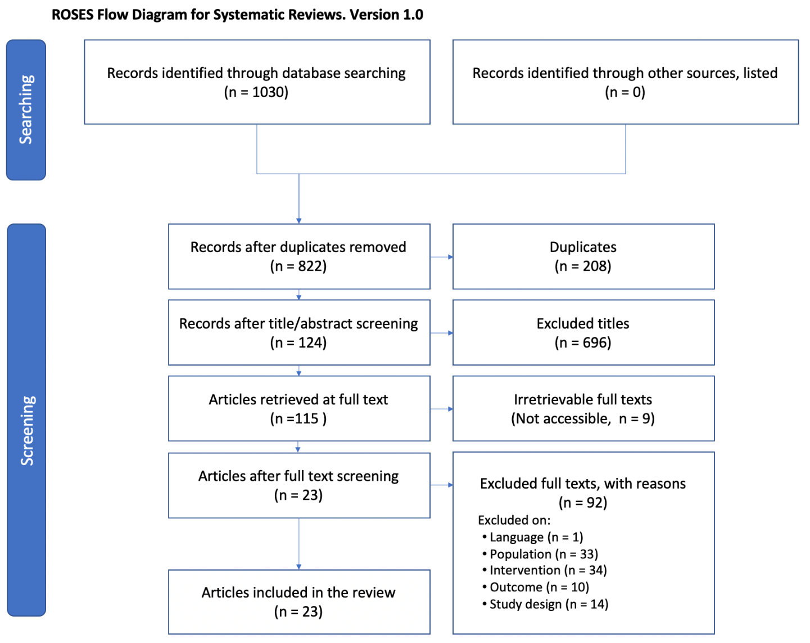
Figure S1. Stages of the rapid evidence review, with inclusion and exclusion of papers. Reference: Haddaway NR, Macura B, Whaley P, and Pullin AS. 2017. ROSES flow diagram for systematic reviews. Version 1.0. DOI: 10.6084/m9.figshare.5897389

Figure S2. The effect of restoration interventions (columns) on the vegetation responses (rows) summarised in the Peatland Synopsis (Taylor et al. 2019b). Each bar shows the proportion of results across the studies that were reported in the Synopsis for each effect of the intervention. The Mixed/conditional effect represents where the response was a mix of positive, negative and/or no change, or was conditional on other factors. See Appendix 5 for full list of specific techniques.

